🔥Top Spring Boot Interview Questions Part 1 | Spring Boot Interview Questions in Hindi

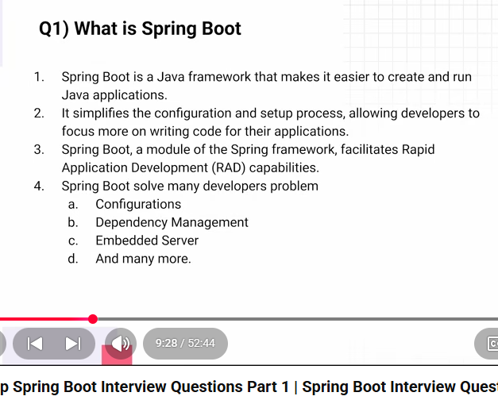
🧠 One-line Interview Answer
Spring Boot supports Rapid Application Development by providing auto-configuration, starter dependencies, embedded servers, and production-ready features out of the box.

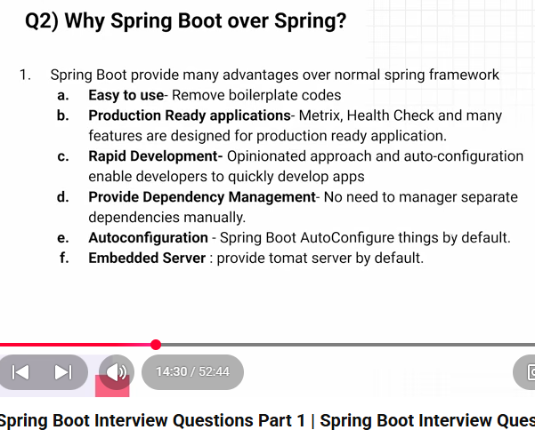
Spring Boot removes boilerplate code by providing auto-configuration, starter dependencies, embedded servers, default setups, and Spring Data repositories, so developers only write business logic, not infrastructure code
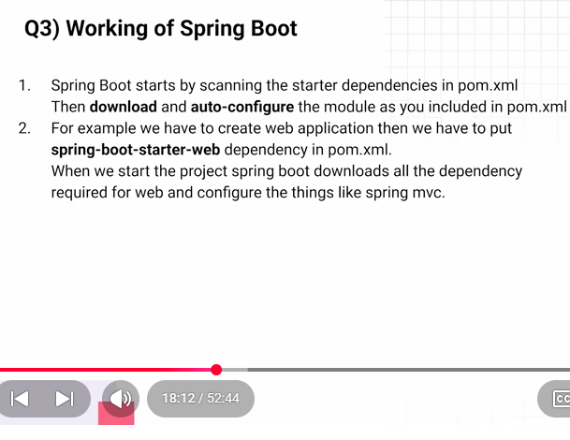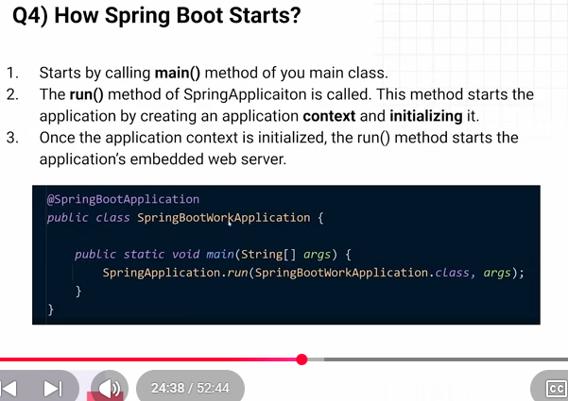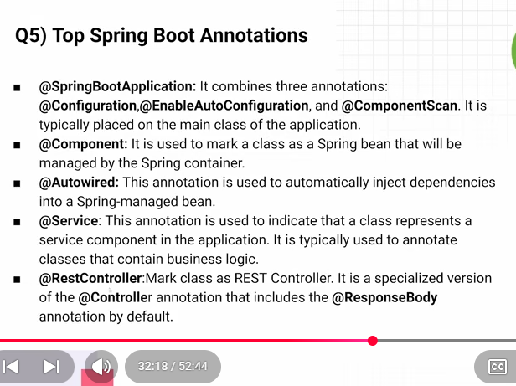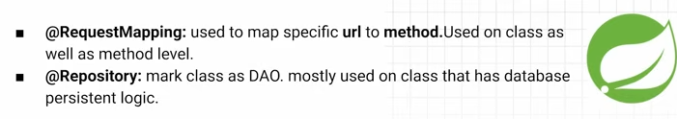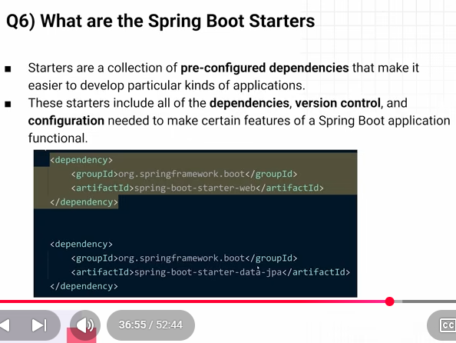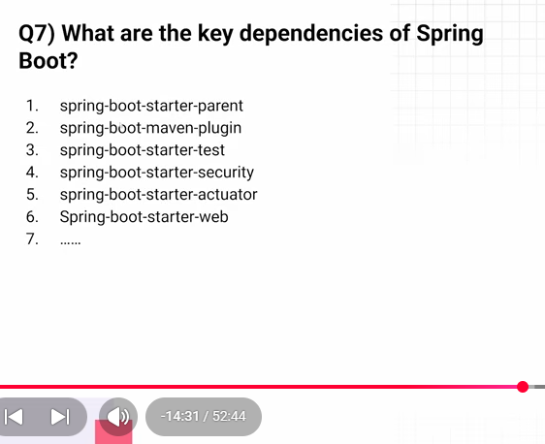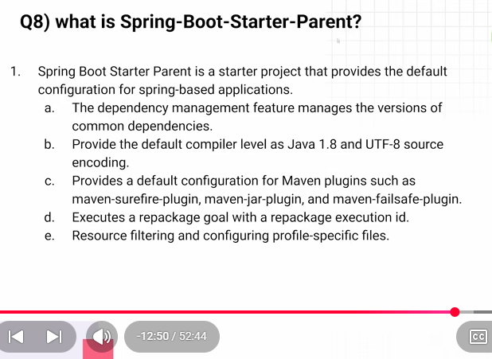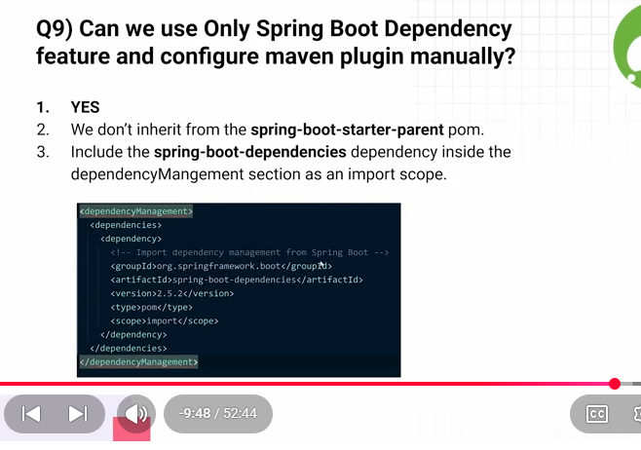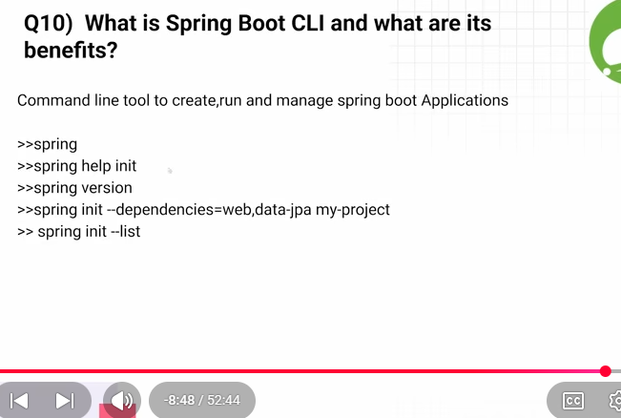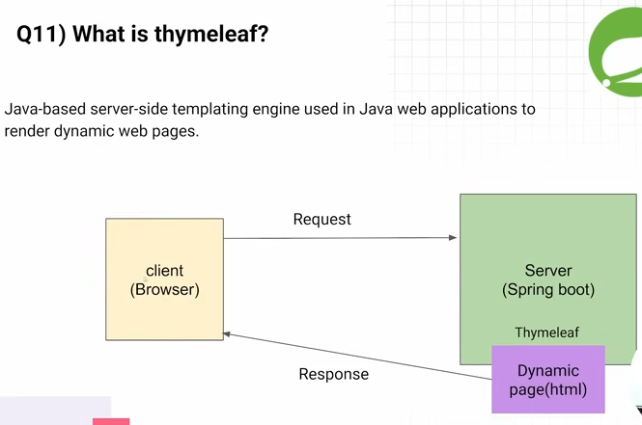

✅ Spring Boot Interview Questions | Part 2
6:46
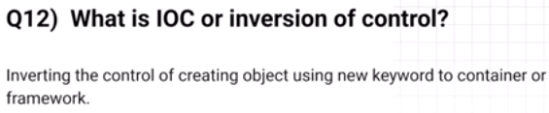
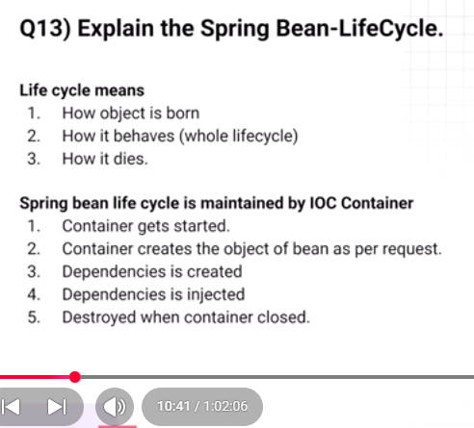
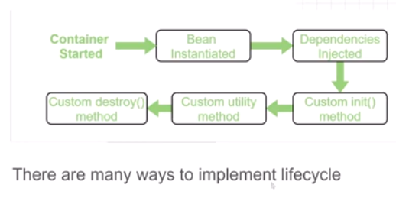
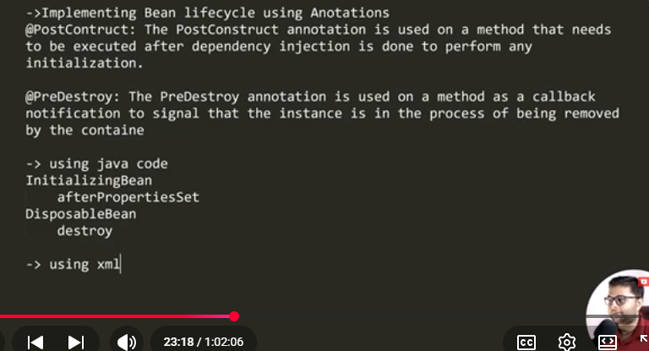
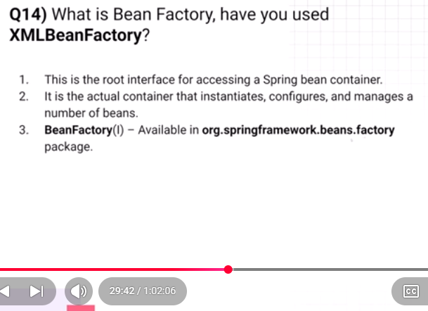
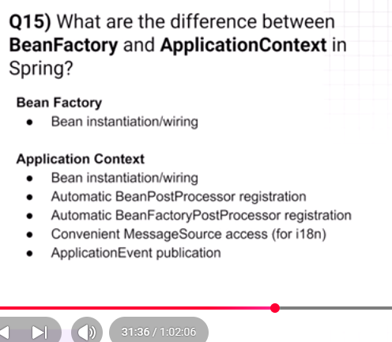
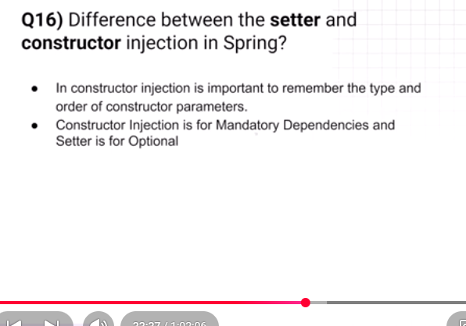
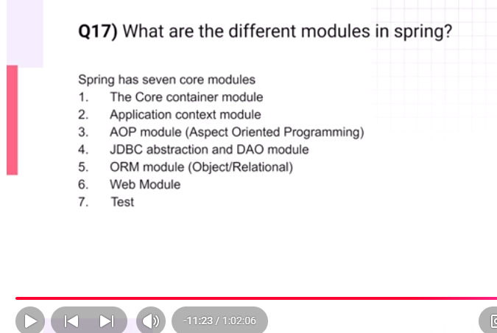
54:32
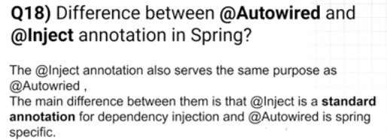
57:25
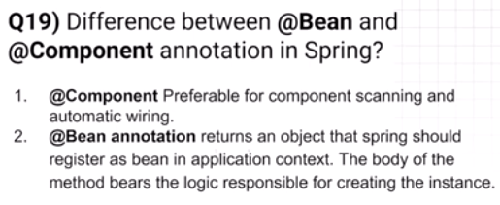
59:24
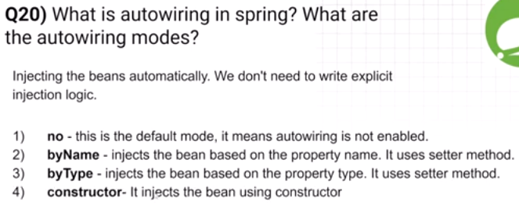
1:01
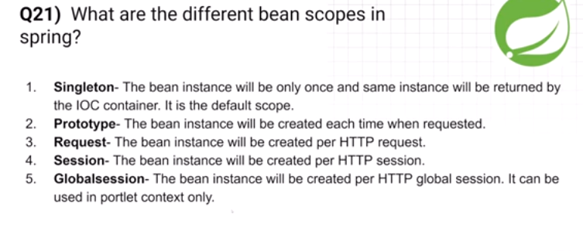

🔥 Top Spring Boot Annotations | Spring Boot Interview Series in Hindi
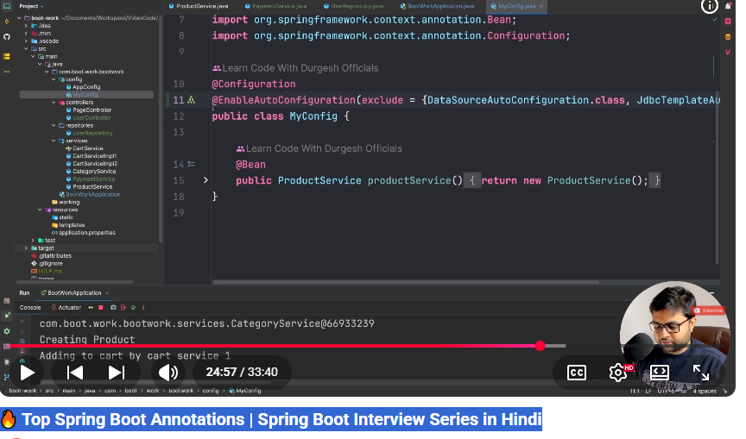

@Import(a.class) : To load specific class from a package manually instead of loading all classes from a packes.Always be used in Configuration class.
Whenever we create a class out of context when we need to import that class,
we can pass multiple class like @import({a.class, B.class})
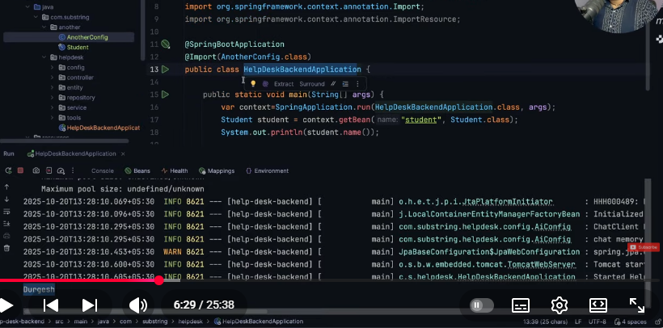
We can also import xml configuratuin file
@ImportResource
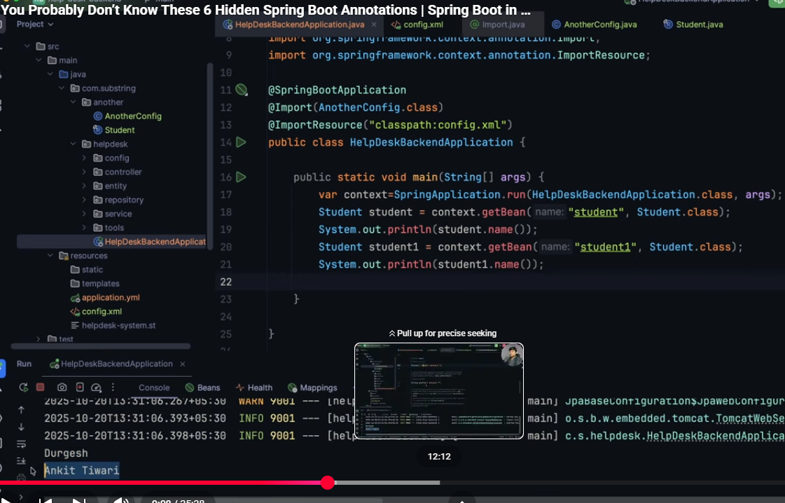
@ConditionalOnProperty and @ConditionalOnClass @conditionalOnBean :
When we want to load a class on meeting of certain condition.
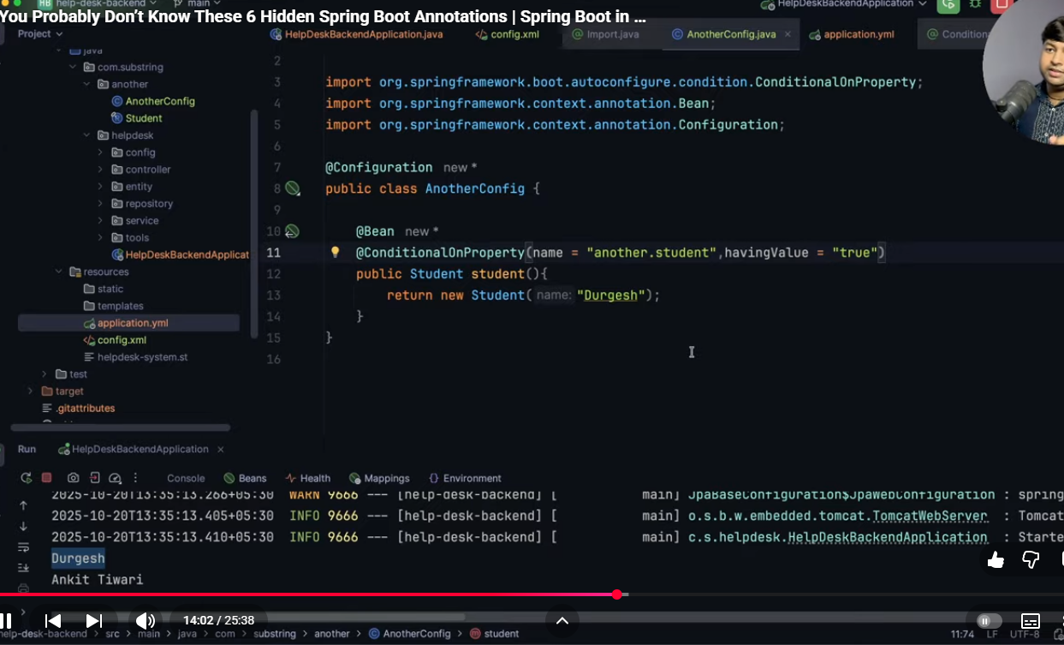
@Profile
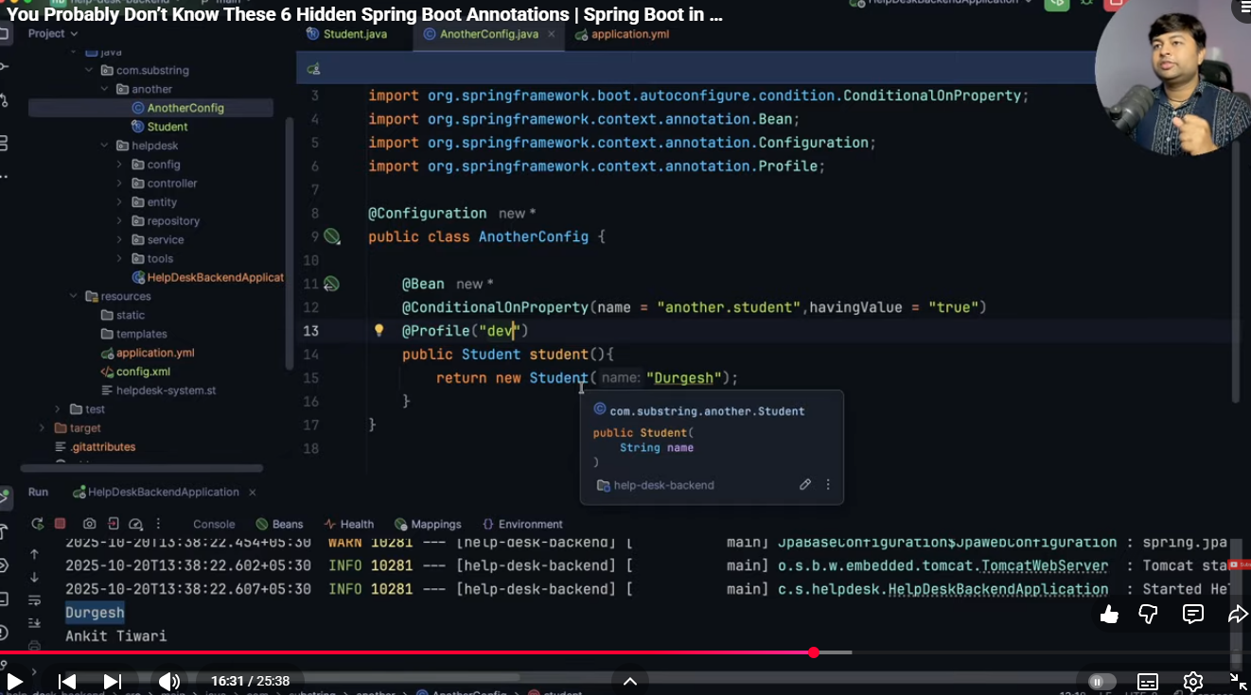

@Lazy
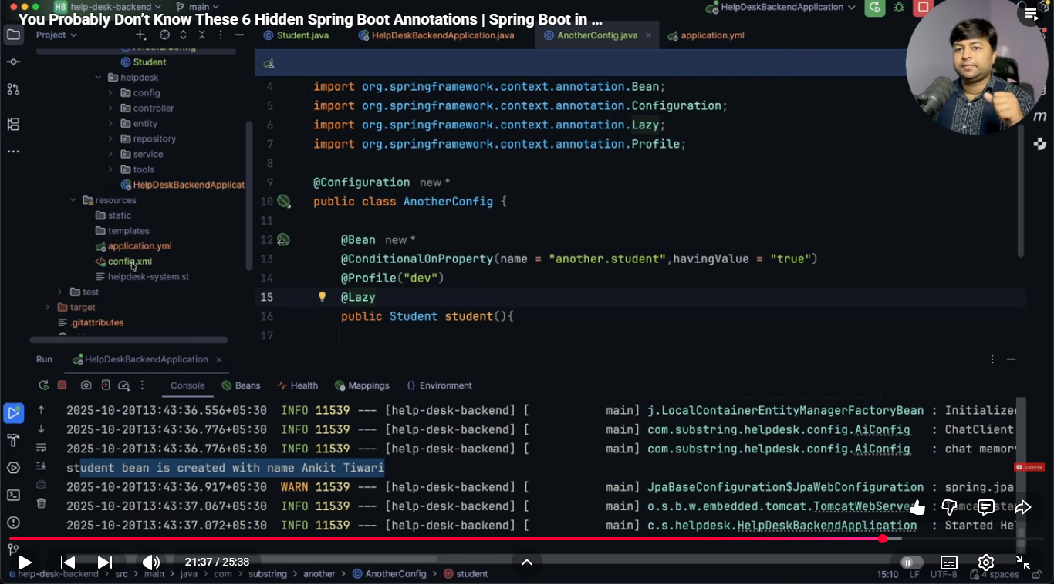
@DependOn : we can control the initialization order that means ensuring one bean load after other bean.
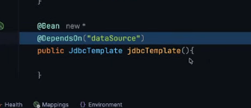
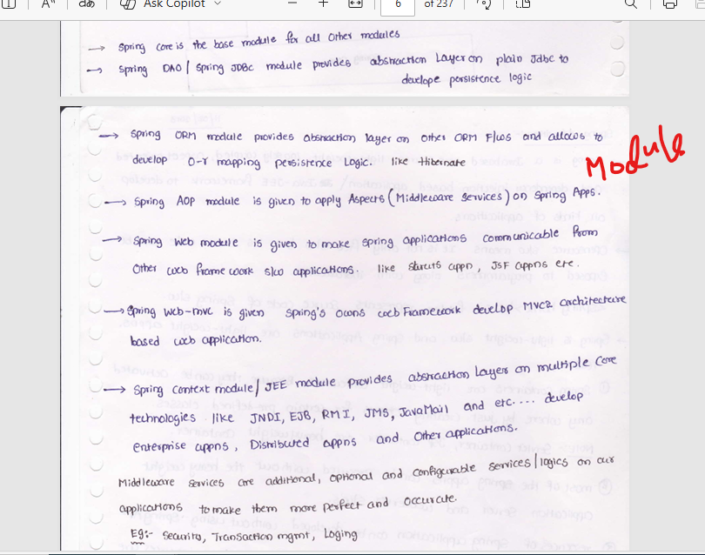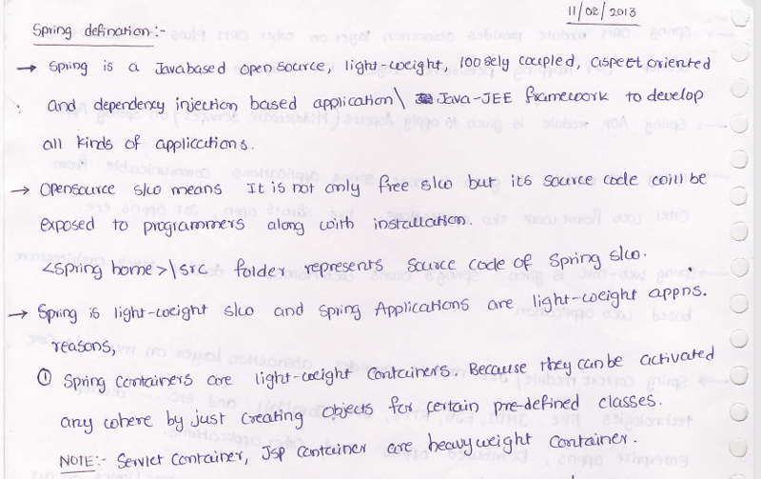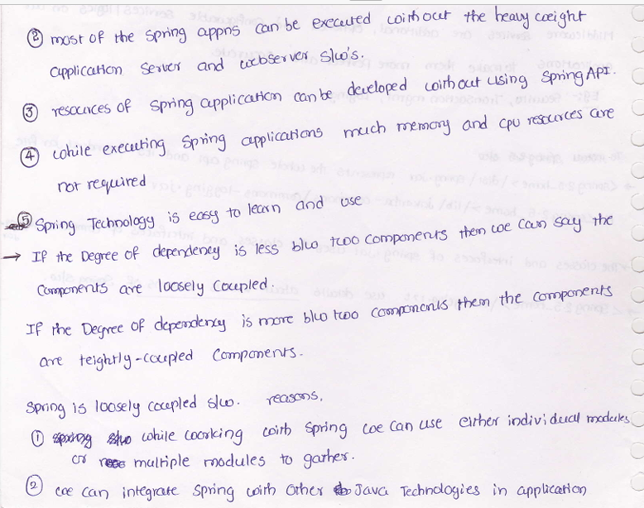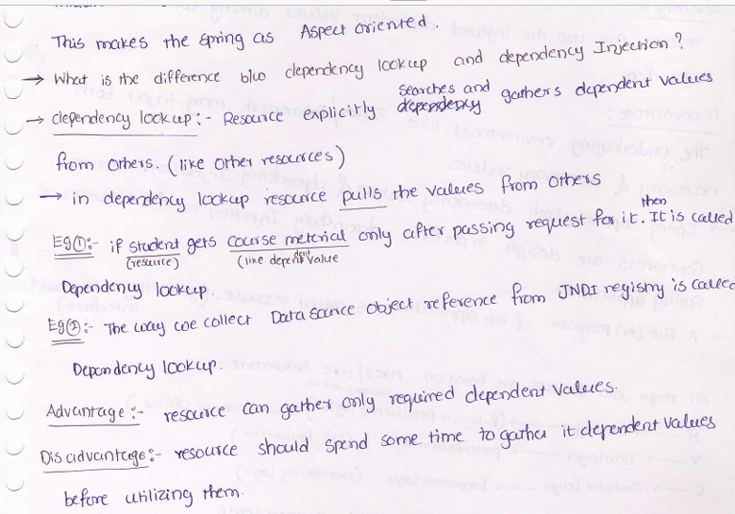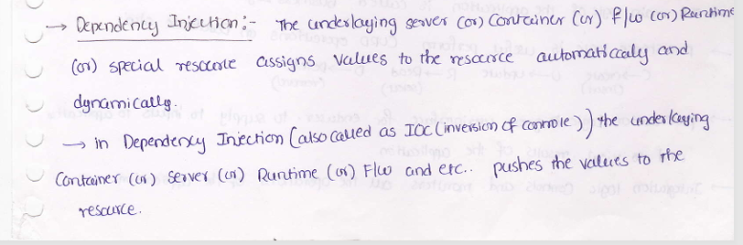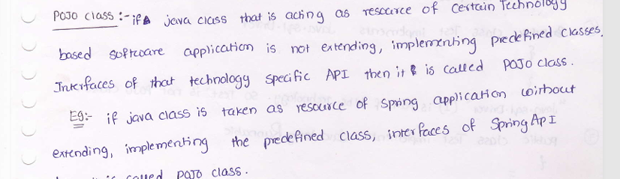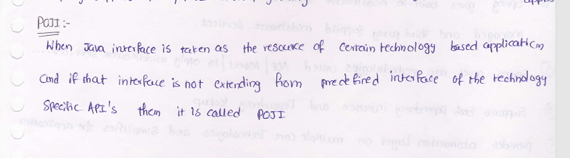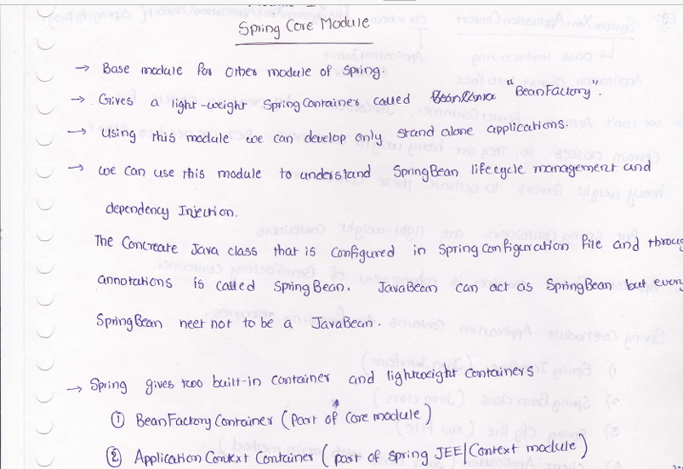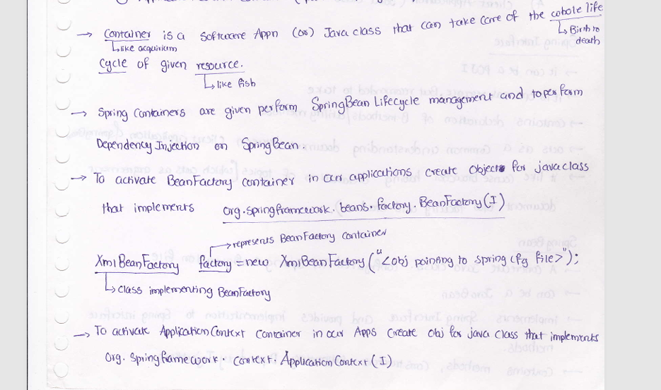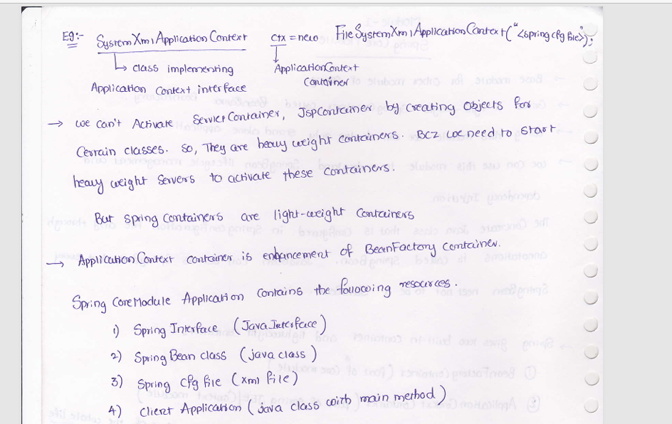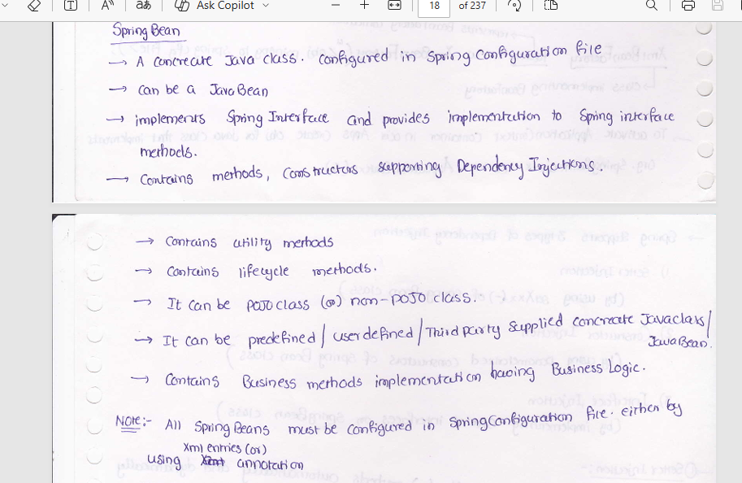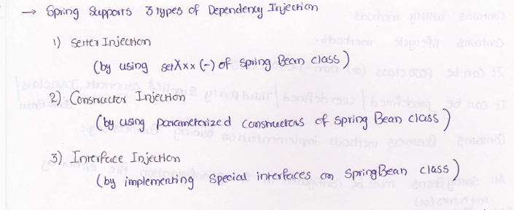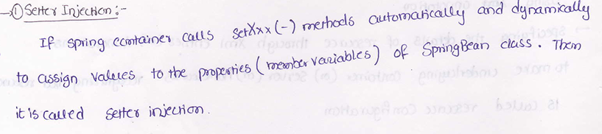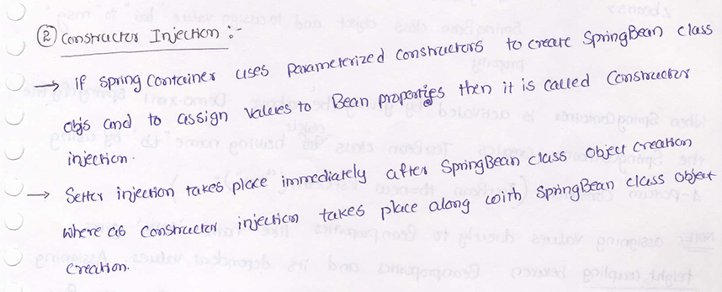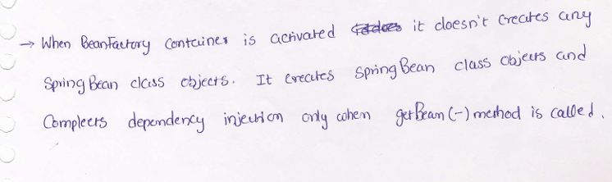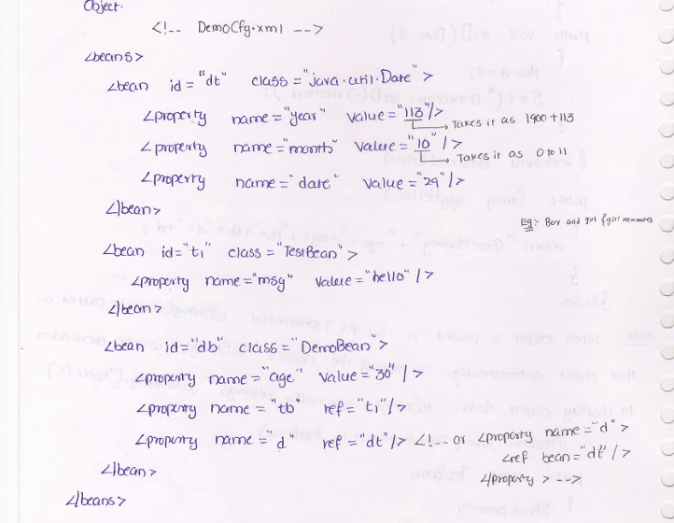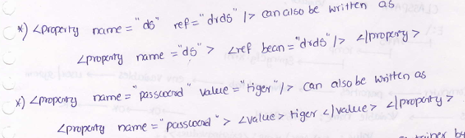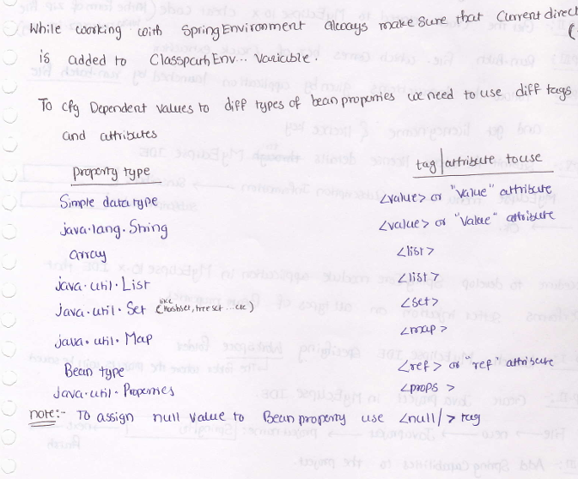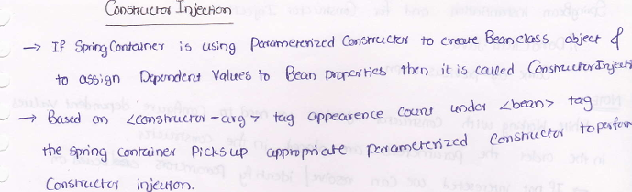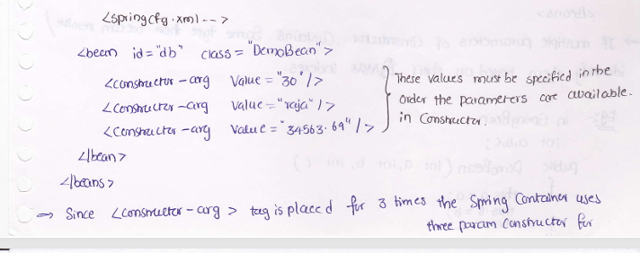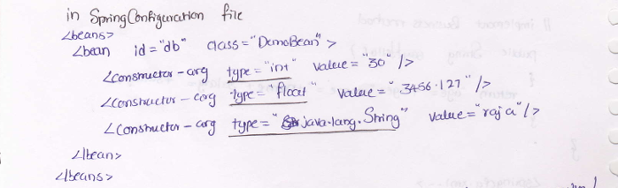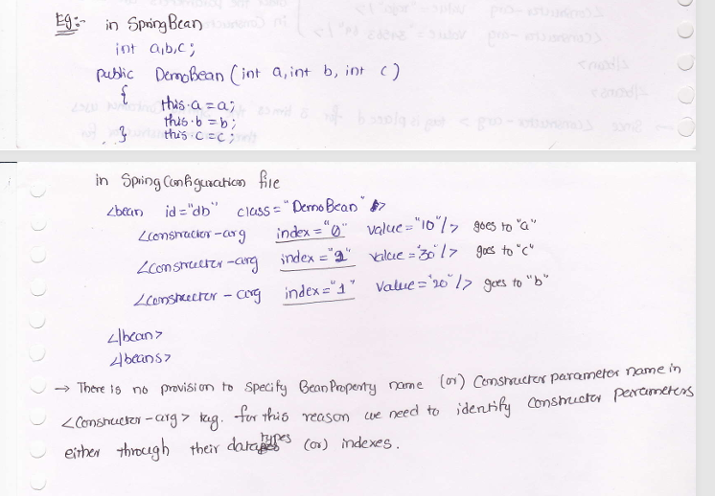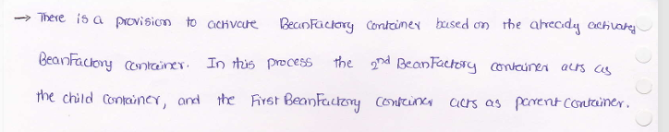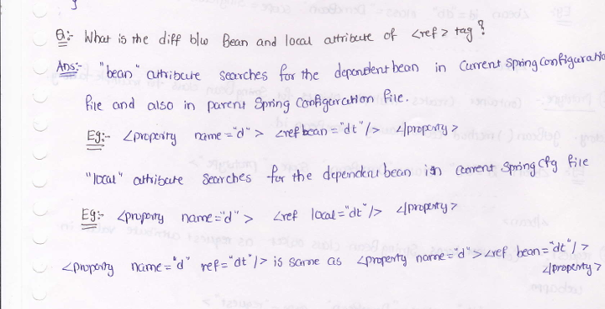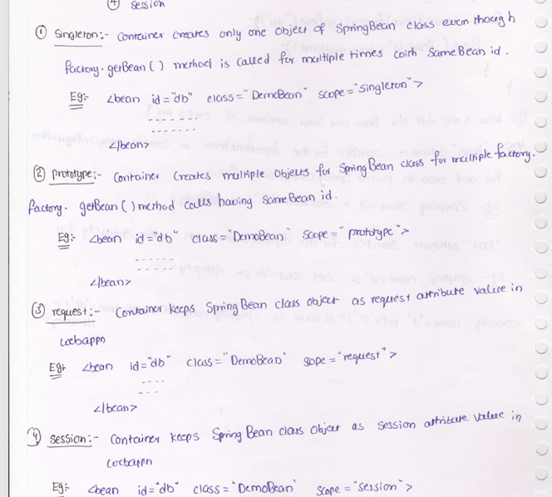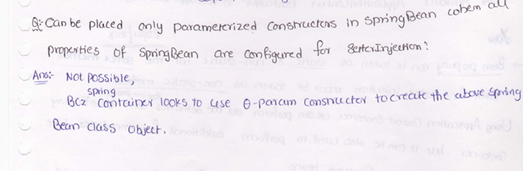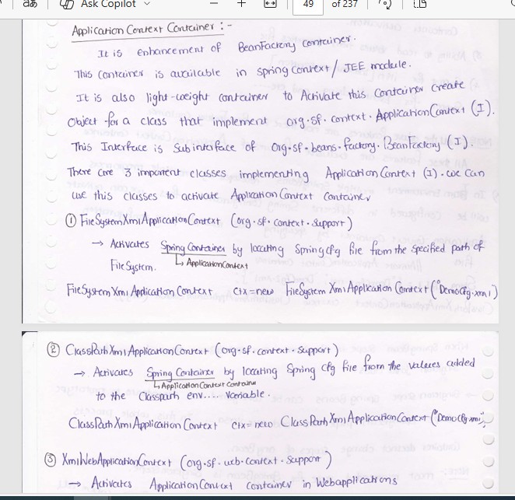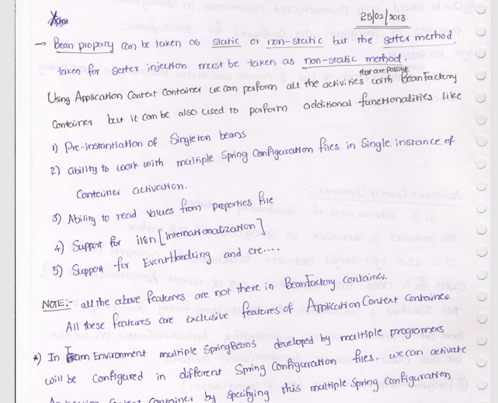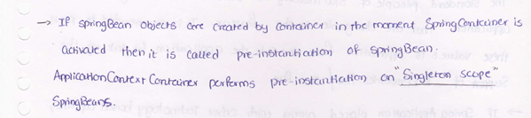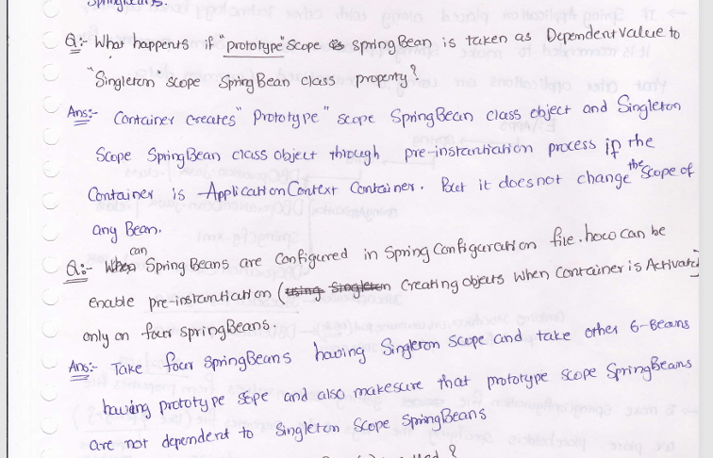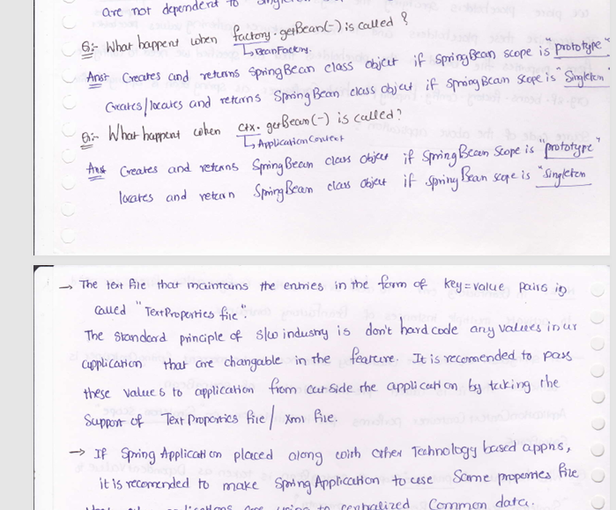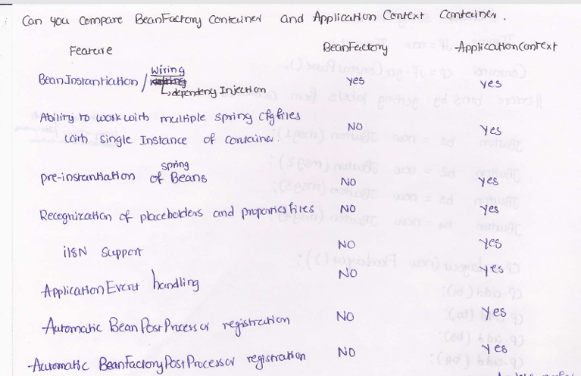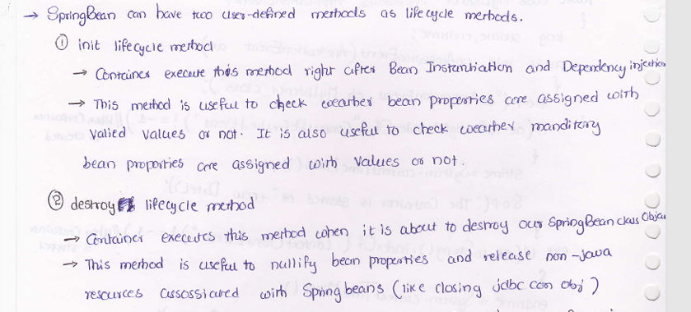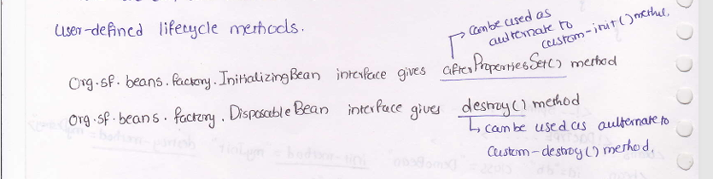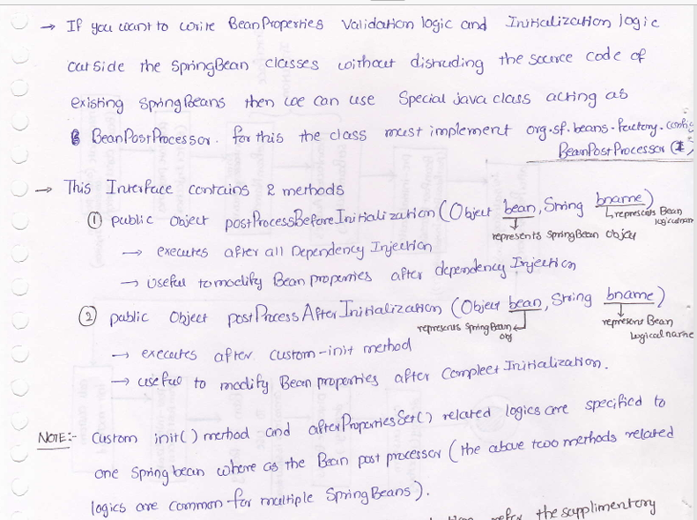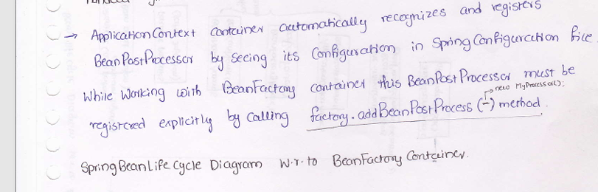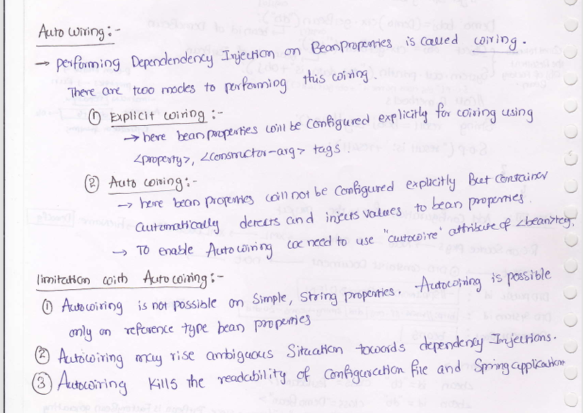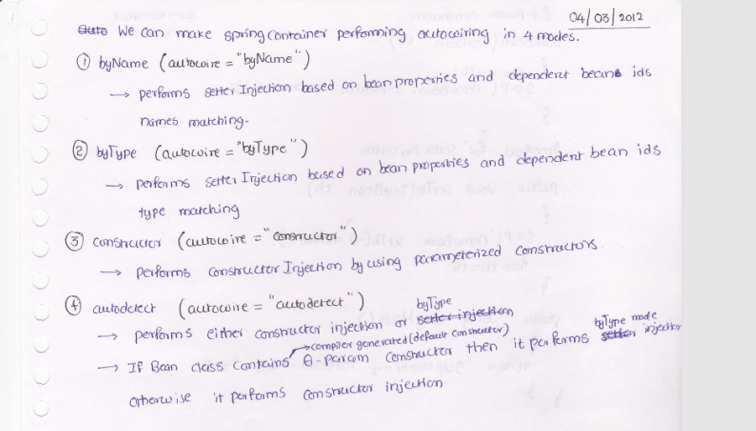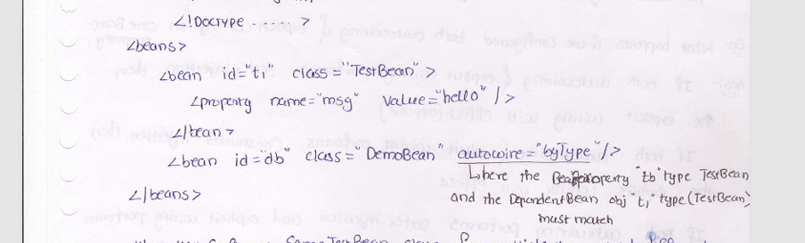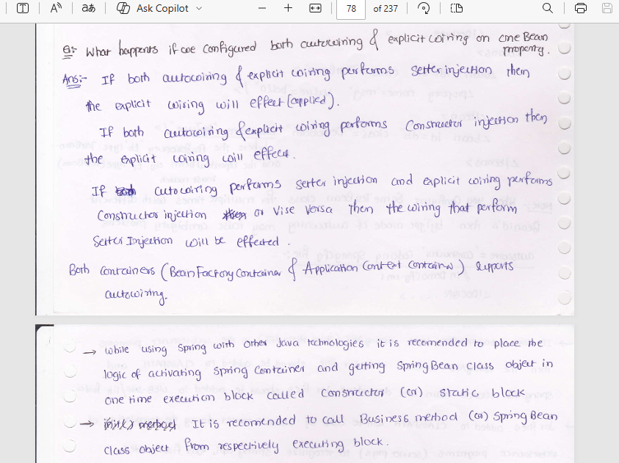

Spring MVC
Got it — you want the complete end-to-end internal flow, including DAO layer, service layer, and how the data comes back to the controller and then to the client.
Here is the full internal working of Spring Boot MVC, the way interviewers actually expect.
------------------------------------------
In Spring Boot MVC, every request is first received by the DispatcherServlet, which uses HandlerMapping to locate the appropriate controller method and HandlerAdapter to invoke it. The controller delegates business logic to the service layer, which in turn calls the DAO or repository layer to fetch data from the database. The data flows back from the repository to the service and then to the controller. The returned Java object is then converted into JSON by HttpMessageConverters and sent back to the client as the HTTP response.
Difference between @ControllerAdvice & @RestControllerAdvice?
@ControllerAdvice is used for global exception handling in traditional MVC applications where responses are views, while @RestControllerAdvice is designed for REST APIs and automatically serializes returned objects into JSON using HttpMessageConverters.
Auto-configuration is a core feature of Spring Boot that automatically configures Spring application components based on the classpath, existing beans, and application properties, without requiring explicit configuration from the developer.

How to optimize spring boot startup time in production?.
1. Lazy Initialization: We need to do initialization as true in properties file.
spring.main.lazy-initialization = true
At the time of startup, only required bean will be loaded.
2.Profile Based Configuration Loading:
@Profile – key annotation
3.Reduce Autoconfiguration:
@SpringBootApplication(exclude={.class, .c;ass})
4.Optimize Component Scanning:
Restrict @ComponentScan to essential packages.
5.GraalVM Native image
6.Reduce jars in classpath : fewer jarz = faster startup
7.

PUT, GET, POST, PATCH, BATCH which Is idempotent
What is Idempotent?
Making the same request multiple times results in the same outcome on the server.
Idempotent HTTP Methods
Method | Idempotent? | Why
GET | ✅ Yes | Only reads data, does not change server state
PUT | ✅ Yes | Replaces a resource completely with same data
PATCH | ❌ No (usually) | Applies partial update; repeated calls may keep changing data
POST | ❌ No | Creates a new resource each time
BATCH | ❌ No | Executes multiple operations (often create/update)

❌ PATCH (Not Idempotent)
PATCH /account/10
{
"balance": "+100"
}Calling it twice → balance increases twice

Which problem is solving
How problem is solving -architecture
Which technology is used to solve the problem like Java my square springboard etc (Tools)

What is your role in that particular project like fully developed the project or individual contract or contributor

What you learning which challenges do you have faced

Dependency Injection:
DI is a design pattern where an object receives its dependencies from the outside, instead of creating them itself
How Spring Resolves Dependencies
1.By Type → EmailService
2.If multiple beans → use name or @Qualifier
3.If still ambiguous → use @Primary
Dynamic URLs Paths
@RequestParam
/employees?id=123 - Use query parameters when the parameter is optional and used for filtering, sorting, or other modifications to the request.
@PathVariable /employees/123 - Use path variables when the parameter is an essential part of the URL path that identifies a resource.
Actuator Endpoints
1. beans: this endpoint returns the list of all the beans configured in our application.
2. env: provides information about the Spring Environment properties.
3. health: Shows application health
4. info: Displays application information, we can configure this in Spring environment properties.
5. mappings: Displays the list of all @RequestMapping paths.
6. threaddump: provides the thread dump of the application.
Actuator Config
To change the base path of actuator
management.endpoints.web.base-path=/management
Enable or Disable actuator
management.endpoints.web.exposure.include=*
Or
management.endpoints.web.exposure.include=health,info,beans,env
Scenario | Status
Success | 200 OK
Created | 201 Created
No response body | 204 No Content
Validation error | 400 Bad Request
Not logged in | 401 Unauthorized
No permission | 403 Forbidden
Data not found | 404 Not Found
Duplicate data | 409 Conflict
Server crash | 500 Internal Server Error

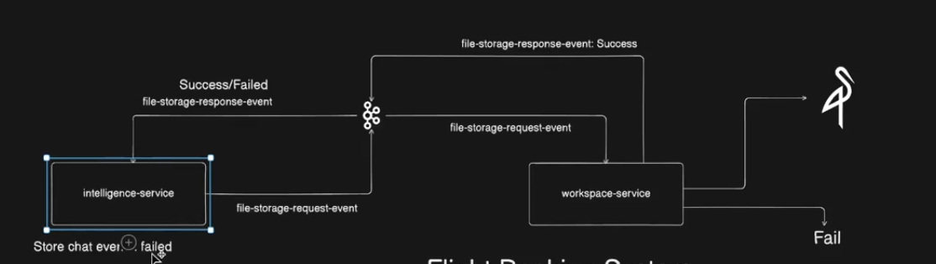
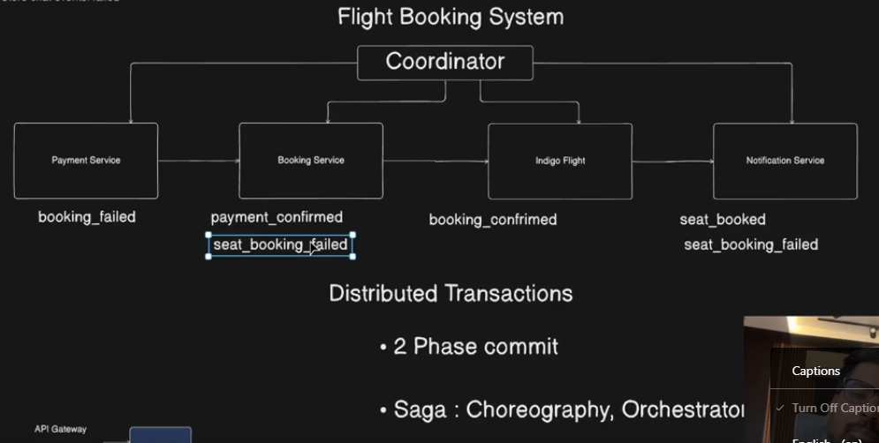
-----------------------------------------------------------------------------------------------------------------------------
🔥 1. What is Pagination in Spring Data JPA?
pending
Pagination means fetching data in chunks (pages) instead of loading all rows at once.
Instead of:
SELECT * FROM users;
We do:
SELECT * FROM users LIMIT 10 OFFSET 20;
Spring Data JPA provides pagination using:
Pageable, Page, Slice

🔥 2. How do you implement pagination in Spring Data JPA?
Pageable pageable = PageRequest.of(0, 10);
Page<User> page = userRepository.findAll(pageable);
Repository:
public interface UserRepository extends JpaRepository<User, Long> { }

🔥 3. Difference between Page, Slice and List?
Feature | Page | Slice | List
Total count query | ✅ Yes | ❌ No | ❌ No
Total pages | ✅ Yes | ❌ No | ❌ No
Next page info | ✅ Yes | ✅ Yes | ❌ No
Performance | Slower | Faster | Fastest

🔥 4. Why is Slice faster than Page?
Page runs two queries:
- Data query
- COUNT(*) query
Slice runs only data query.
So for infinite scrolling, use:
Slice<User> findByStatus(String status, Pageable pageable);

🔥 5. How does Spring Data JPA generate pagination SQL?
If you write:
Page<User> findAll(Pageable pageable);
Hibernate generates:
select * from user limit 10 offset 20;
select count(*) from user;

🔥 6. How do you apply pagination to custom query?
@Query("select u from User u where u.status = :status")
Page<User> findByStatus(@Param("status") String status, Pageable pageable);

🔥 7. What is Pageable?
Pageable is an interface that contains:
- page number
- page size
- sort info
Created using:
PageRequest.of(page, size, Sort.by("name").descending());

🔥 8. How do you get page metadata?
Page<User> page = repo.findAll(pageable);

page.getTotalPages();
page.getTotalElements();
page.getNumber();
page.getSize();
page.hasNext();

🔥 9. Difference between offset pagination and keyset pagination?
Offset Pagination | Keyset Pagination
Uses OFFSET | Uses last seen ID
Slow for large data | Very fast
Can skip rows | Stable
Spring Data JPA default uses Offset pagination.

🔥 10. How to implement pagination in Controller?
@GetMapping("/users")
public Page<User> getUsers(
@RequestParam int page,
@RequestParam int size) {

Pageable pageable = PageRequest.of(page, size);
return userRepository.findAll(pageable);
}

🔥 11. How do you avoid COUNT(*) query?
Use Slice instead of Page:
Slice<User> findByStatus(String status, Pageable pageable);

🔥 12. Can we use pagination with native queries?
Yes:
@Query(value="select * from users",
countQuery="select count(*) from users",
nativeQuery=true)
Page<User> findUsers(Pageable pageable);

🔥 13. What happens if Pageable is not passed?
Spring fetches all records → can cause OutOfMemoryError.

🔥 14. How does Spring know which page to return?
From:
PageRequest.of(page, size)
It calculates:
OFFSET = page × size

🔥 15. Real-world use cases
- REST APIs
- Infinite scrolling
- Admin dashboards
- Large reports

If you want, I can also give you:
- Tricky pagination interview questions
- Hibernate pagination pitfalls
- Keyset pagination using JPA
- Pagination with JOINs (very common interview trap)
yes
Perfect — here are the tricky, real-world Spring Data JPA Pagination interview traps that interviewers love to ask
(These separate mid-level from senior-level developers.)

🔥 1. Why is pagination with JOIN dangerous?
@Query("select u from User u join u.orders o")
Page<User> findUsers(Pageable pageable);
This causes duplicate rows at SQL level.
If a user has 5 orders → same user appears 5 times → pagination breaks.

❌ Result
Page size = 10
But you may get only 3 users.

✅ Fix
Use DISTINCT:
@Query("select distinct u from User u join u.orders o")
Page<User> findUsers(Pageable pageable);

🔥 2. Why is count(*) wrong with JOIN?
Spring generates:
select count(*) from users u join orders o
This counts rows, not users.

Correct way
Provide custom countQuery:
@Query(
value = "select distinct u from User u join u.orders o",
countQuery = "select count(distinct u.id) from User u join u.orders o"
)
Page<User> findUsers(Pageable pageable);

🔥 3. Why does pagination get slow for large tables?
Because OFFSET pagination scans skipped rows:
LIMIT 10 OFFSET 1000000
DB must read 1M rows before returning 10 → very slow.

🔥 4. How to solve large-offset pagination? (Keyset pagination)
Instead of:
OFFSET 100000
Use:
WHERE id > lastSeenId
ORDER BY id
LIMIT 10
JPA:
List<User> findByIdGreaterThan(Long lastId, Pageable pageable);
This is O(1) instead of O(n).

🔥 5. Why is Page dangerous in infinite scroll?
Because it executes:
select count(*)
on every request → huge DB load.

Use Slice instead:
Slice<User> findAll(Pageable pageable);

🔥 6. What happens if sorting column is not indexed?
Pagination + sorting = full table scan.
Example:
PageRequest.of(0, 10, Sort.by("email"))
If email is not indexed → DB will scan entire table.
Always index sorting columns.

🔥 7. Why pagination gives inconsistent results sometimes?
When rows are inserted/deleted between page calls.
Page 1:
IDs: 1–10
New record inserted
Page 2:
IDs: 10–19 → 10 appears twice

Fix → use stable sorting
PageRequest.of(0,10, Sort.by("id"))

🔥 8. Why findAll(Pageable) may cause N+1 problem?
If entity has lazy relationships:
Page<User> page = repo.findAll(pageable);
page.getContent().forEach(u -> u.getOrders().size());
This causes:
1 query for users
+ N queries for orders

Fix
Use fetch join:
@Query("select distinct u from User u left join fetch u.orders")
Page<User> findAllWithOrders(Pageable pageable);

🔥 9. Can Pageable be passed automatically from REST?
Yes.
@GetMapping("/users")
public Page<User> getUsers(Pageable pageable) {
return repo.findAll(pageable);
}
URL:
/users?page=1&size=20&sort=name,desc

🔥 10. What is the biggest pagination mistake?
Using:
List<User> findAll();
on large tables.
This loads everything into memory → OutOfMemoryError.

🧠 Interview Gold One-Liner
“Spring Data JPA pagination works by translating Pageable into SQL LIMIT/OFFSET, but for large datasets or joins, it must be optimized using DISTINCT, custom count queries, and sometimes keyset pagination to avoid performance issues.”

